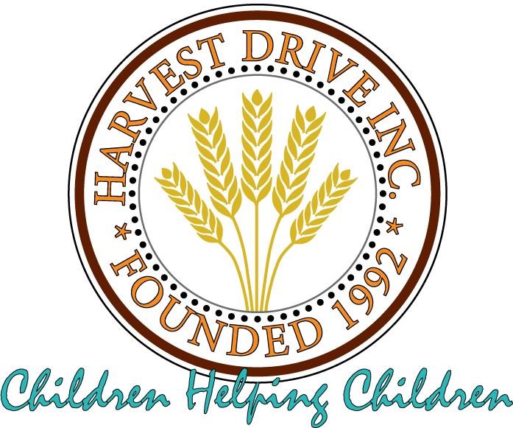

Realities of Hunger

1 in 8 Americans is food insecure. 1 in 6 children in America are food insecure.

This means they are often forced to skip meals, eat less at meals, buy cheaper non-nutritious food and/or adults feed their children but not themselves. This also means that individuals and families must choose between purchasing food and paying rent, utilities, or medical bills.

In South Florida 1 in 8 people are food insecure and 1 in 5 children struggle with hunger.

265,760 people (14.3%) in Broward County are food insecure. 18.6% of children in Broward County are food insecure, meaning 74,730 children go to bed hungry. 25% of these individuals and families do not qualify for any state or federal food benefits. This is where it is essential that community organizations step in.

Most individuals who do not have enough money to purchase food also do not have enough basic necessities such as a toothbrush & toothpaste, dental floss, deodorant, shampoo & conditioner, soap, food storage bags, and multi-surface cleaners. It’s hard to present your best self when you aren’t clean.

Most households being served by Feeding America have at least one employed person living in them. The job may pay too much for them to qualify for government benefits, but it’s not enough to provide for a family.

Food insecurity is not the same thing as poverty. Food insecurity can result from unexpected circumstances such as job loss, underemployment, personal illness, or caring for a sick child or aging relative. It’s also important to recognize that in Florida, salaries in the past six years have not kept up with the increases in the cost of living.

Providing for a family as a single parent with high daycare expenses can prove very challenging, especially for low wage earners.

Additional negative effects of hunger can include food-related illnesses such as type 2 diabetes, high blood pressure, heart disease or obesity as well as academic struggles and behavioral problems.

These Hunger Facts and additional information can be found at Feedingamerica.org.

